إستراتيجية حل المسألة
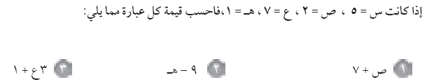
2 + 7 = 9 9 – 1 = 8 3 × 7 + 1 = 21 + 1 = 22
5 × 5 – 4 = 25 – 4 = 21 7 – 2 = 5 1 + 5 = 6
11 × 7 – 7 = 77 – 7 = 70 6 + 3 × 1 = 6 + 3 = 9 4 × 5 – 10 × 2 = 20 – 20 = 0
3 × 21 = 3 × 1 = 3 2 × 27 = 2 × 49 = 98 25 + 8 = 25 + 8 = 33
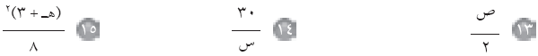
( 1 + 3 )2
8
²4
8
=
=
16
8
=
2
= 1 = 6

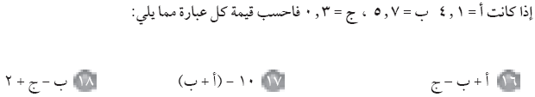
4.1 + 5.7 – 0.3 = 9.5 10 – ( 4.1 + 5.7 ) = 0.2 5.7 – 0.3 + 2 = 7.4

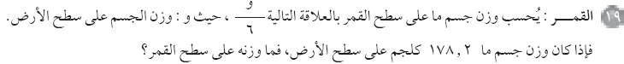
وزن الجسم على سطح القمر = = = 29.7 كلجم

س | 16 س
1 | 16 × 1 = 16
2 | 16 × 2 = 32
3 | 16 × 3 = 48
4 | 16 × 4 = 64
5 | 16 × 5 = 80

